# Meeting Minutes on 5 Oct 2024

Attendees: Stephen, Tan Yuan, Jun Jie, Lai

We kicked off our first capstone project meet-up after forming the team with the following agenda, discussion and next-steps:

* Recap the scope of the training programme’s capstone project.
  + “These capstone projects are designed to enable learners to familiarize with cloud technologies and their use cases such as DevOps, DevSecOps and Site Reliability. Each use case focuses on different aspects of software deployments. A team size of 3 or 4 pax is expected to undertake the project.” - from the CE - CAPSTONE PROJECT” doc.
* Define the combined use-case of our project implementation scope.
  + SRE ‘observable and traceable’ monitoring of a ML application with simple CICD pipeline including dependencies/vulnerabilities screening for blue-green deployment.
    - The example ML application is about Insurance Cross-Selling Prediction. It predicts which customer segment profiles are most likely to purchase additional insurance products. It uses 3 different machine learning models based upon the decision tree, gradient boosting and random forest classification algorithms. The application will be cloud-native, published as APIs and shall be deployed in Dockers/Kubernetes.
  + The programme’s indicated project completion criterions are as follow:
    - No CICD Required (?).
    - Only one environment suffix (?).
    - Application logging must be centrally managed.
    - Systems health must be centrally managed.
    - Produce a dashboard that shows applications and systems logs.
  + (?) However we discussed and concluded that we shall include a simple CICD pipeline for dev, uat and prod environments. So modifying the first two criterions stated above.
* The solution component architecture is as follows:

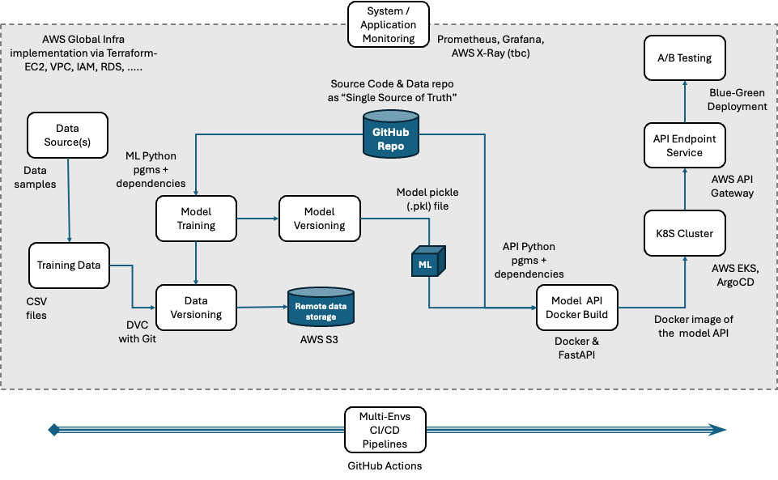

Next Steps:

1. Each of us will conduct further R&D on some of the components to learn and study more prior to the start of the capstone project implementation. This will also include defining the demo ‘user story’ scope.
   1. Stephen, Tan Yuan - Model API Docker image build, EKS, ArgCD, API Gateway, Blue-Green deployment for A/B testing, end-to-end observability & traceability.
   2. Jun Jie - Prometheus, Grafana for system monitoring, ML model training, ML model & data versioning, Git strategy, CICD pipeline hi-level design